Project Context (Quick Recap)
Domain: Personal Finance Analytics
Objective: Build an end-to-end analytics platform to track expenses, income, budgets, and savings.
GCP Services Used
- Cloud Storage (Bronze)
- Cloud SQL – PostgreSQL (Silver)
- BigQuery (Gold)
- Cloud Run (Python ETL)
- Cloud Scheduler
- Looker Studio

HIGH-LEVEL ARCHITECTURE (HLD)
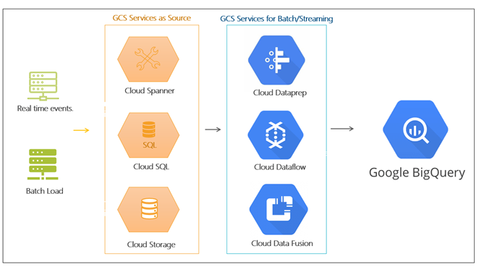
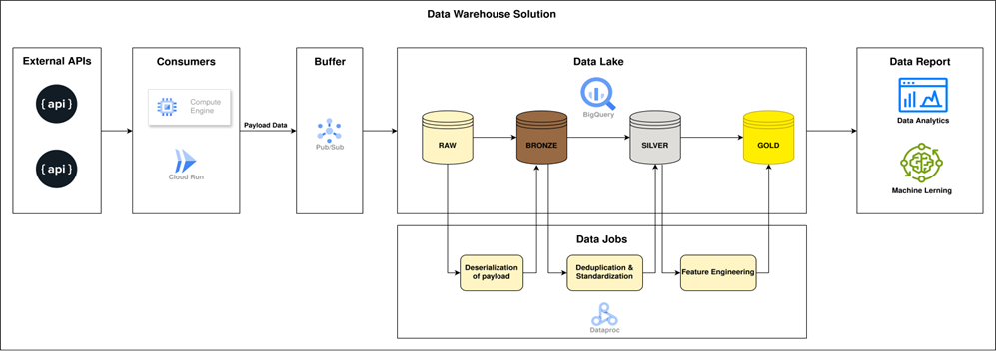
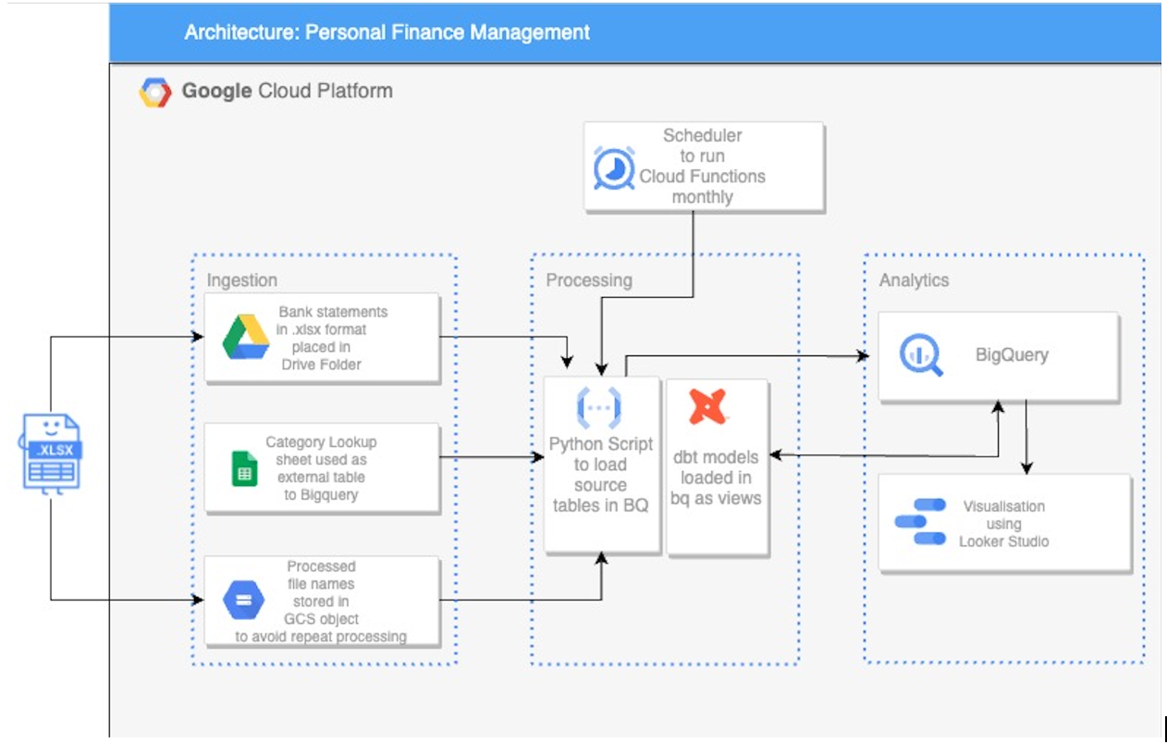

Flow
CSV / User Input
↓
Cloud Storage (Bronze)
↓
Python ETL (Cloud Run)
↓
Cloud SQL (Silver)
↓
BigQuery (Gold)
↓
Looker Studio

🧩 LOW-LEVEL DESIGN (LLD – Component View)
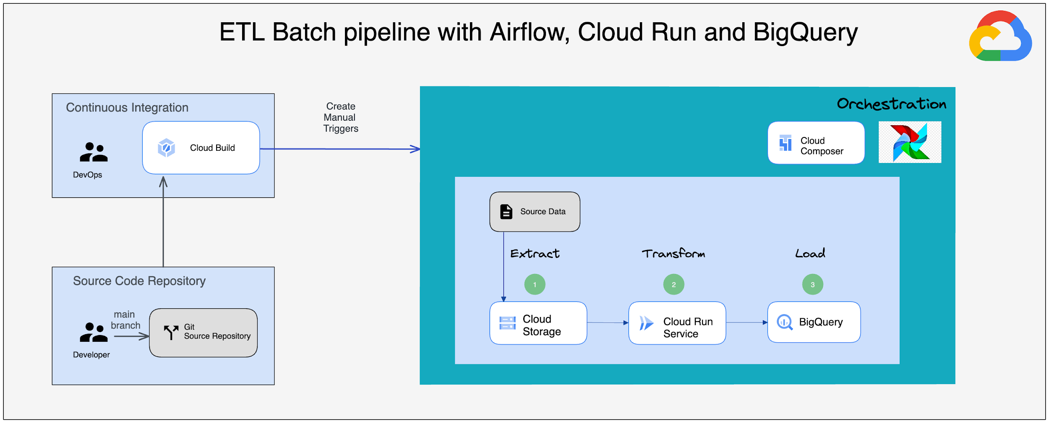
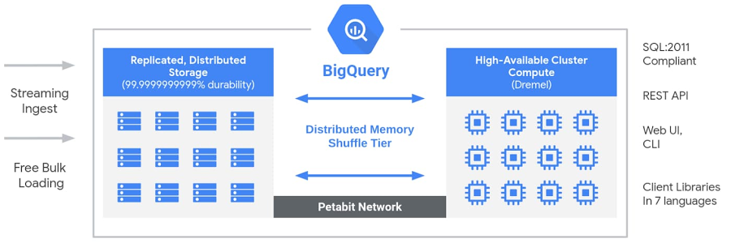
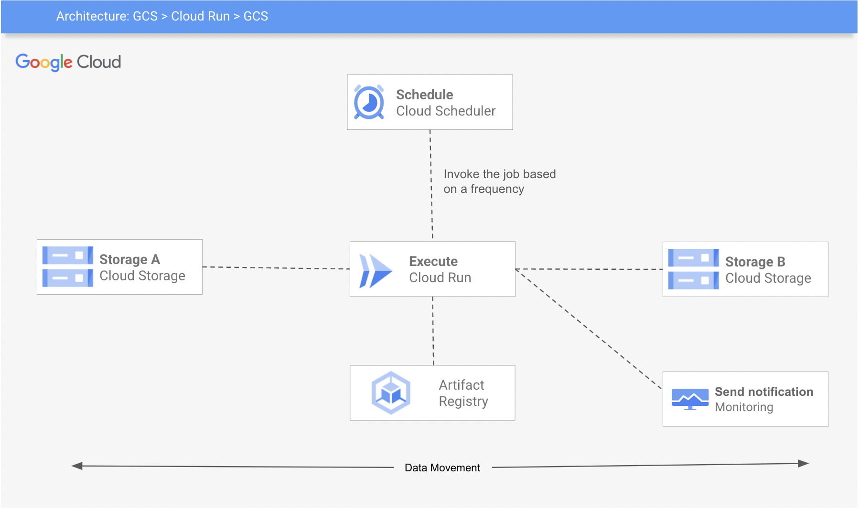

Storage Layers
Layer | Service | Purpose
Bronze | Cloud Storage | Raw CSV preservation
Silver | Cloud SQL | Cleaned, relational data
Gold | BigQuery | Analytics & reporting

👥 TEAM STRUCTURE (5 PEOPLE)
Person | Role | Responsibility
P1 | GCP Infra Lead | Project setup, IAM, networking
P2 | Data Engineer | Ingestion, Cloud Storage, ETL
P3 | Backend Engineer | Cloud Run, Python jobs
P4 | Analytics Engineer | BigQuery modeling, SQL
P5 | BI Engineer | Looker dashboards & KPIs

🟦 DAY-WISE SPRINT PLAN (6 DAYS)

🟩 DAY 1 – Project Setup & Dataset Understanding

Owner
- P1 (Infra)
- P2 (Data Engineer)

Step-by-Step Tasks
- Create GCP Project
- Enable APIs:
  - Cloud Storage
  - Cloud SQL
  - BigQuery
  - Cloud Run
  - Cloud Scheduler
Create GCS buckets:
gs://finance-raw-data/
├── expenses/
└── income/

- Review datasets:
  - Expense CSV
  - Income CSV
- Define KPIs:
  - Monthly expense
  - Monthly income
  - Savings
  - Budget utilization %
Deliverable
- Dataset understanding doc
- KPI definition sheet

🟩 DAY 2 – Bronze Layer (Raw Ingestion)

Owner
- P2 (Data Engineer)

Step-by-Step Tasks
- Upload raw CSVs into Cloud Storage
- Preserve:
  - Original timestamps
  - Original category names
Define naming convention:
expenses_YYYYMM.csv
income_YYYYMM.csv

- Validate file arrival manually
Deliverable
- Raw data available in GCS
- Folder & naming standards

🟩 DAY 3 – Silver Layer (Cleaning & Cloud SQL)

Owner
- P3 (Backend)
- P2 (Data Engineer)

Step-by-Step Tasks
- Create Cloud SQL (PostgreSQL)
- Create tables:
expenses(id, date, category, amount)
income(id, date, source, amount)

- Write Python ETL:
- Read CSV from GCS
- Handle nulls
- Standardize categories
- Remove duplicates
- Load cleaned data into Cloud SQL
Deliverable
- Clean relational tables
- Python ETL script

🟩 DAY 4 – Gold Layer (BigQuery Modeling)

Owner
- P4 (Analytics Engineer)

Step-by-Step Tasks
- Extract data from Cloud SQL
- Load into BigQuery tables
- Create analytics views:
monthly_expense
monthly_income
budget_vs_actual

- Apply partitioning:
PARTITION BY DATE(transaction_date)

- Optimize queries
Deliverable
- BigQuery datasets
- Optimized SQL views

🟩 DAY 5 – Automation & Scheduling

Owner
- P3 (Backend)
- P1 (Infra)

Step-by-Step Tasks
- Containerize ETL using Docker
- Deploy ETL to Cloud Run
- Create Cloud Scheduler job:
- Monthly execution
- Validate automated pipeline
- Add logging & error handling
Deliverable
- Automated pipeline
- Cloud Run service + Scheduler

🟩 DAY 6 – Visualization & Insights

Owner
- P5 (BI Engineer)

Step-by-Step Tasks
- Connect BigQuery to Looker Studio
- Build dashboards:
- Monthly expense trend
- Category-wise spend
- Budget vs actual
- Savings trend
- Validate KPIs
- Create demo walkthrough
Deliverable
- Looker dashboard
- Final demo-ready project

📌 FINAL DELIVERABLES (After 6 Days)
- End-to-end GCP data pipeline
- Automated ingestion & transformation
- Analytics-ready BigQuery models
- Business dashboards
- Clear Bronze → Silver → Gold story

🎯 Why This Is STRONG for Interviews & Training
- Realistic finance use case
- Full GCP stack usage
- Clear role ownership
- Step-by-step traceability
- Easy to defend architecture decisions

